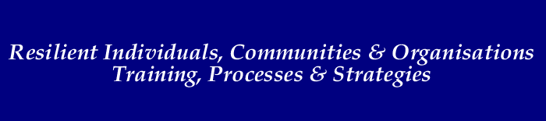
Supervision

What is Supervision?
Supervision is a process which provides an individual with the opportunity to clarify and resolve issues and dilemmas presented by their clients and workplaces. It is widely used by human services workers and teams. The supervision process has been found to reduce the risk of burn-out, enhance work performance and increase job satisfaction.
The purpose of the supervision process is to provide a safe, supportive opportunity for individuals to engage in critical reflection in order to raise issues, explore problems, and discover new ways of handling both the situation and oneself.
A critical aspect of supervision lies in its potential to educate. It is the supervisor's responsibility to ensure that:
- professional development and an ability to handle the various work tasks is fostered in the supervisee.
- an educative forum, and a non-patronising relationship, is established in which the supervisee can comfortably explore issues with the support of the supervisor.
- guidance and tutoring are available where necessary.

The key functions of supervision
One of the most influential writers on supervision is Charles Kadushin (1992) who defined three main functions of the supervisory process:
- Educational - the educational development of the practitioner and the fulfilment of potential. In educational supervision the primary focus is to dispel ignorance and upgrade skill by encouraging reflection on, and exploration of the work.
- Support - the practical and psychological support to carry through the responsibilities of the role. In supportive supervision the primary issue is worker morale and job satisfaction. The stresses and pressures of the individual's role can affect work performance and take its toll psychologically and physically. In extreme and prolonged situations these may ultimately lead to burnout. The supervisor's role is to help the worker manage that stress more effectively and provide re-assurance and emotional support.
- Administrative/Managerial - the promotion and maintenance of good standards of work, co-ordination of practice with policies of administration, the assurance of an efficient and smooth-running office; This is the quality assurance dimension to supervision. The interpretation here is that the supervisor inducts the coach into the norms, values and best practices of being a practitioner/professional. It is the 'community of practice' dimension ensuring that standards are maintained.

The supervision process:
At the start of the supervision process, the parties concerned work out:
- regularity of supervision (eg. two hours every month)
- aims and objectives of supervision (eg. to address worker issues? to set tasks?)
- conditions under which supervision is to take place (eg. will matters discussed be strictly confidential?).
Because supervision is a process it does not start and conclude within a set timeframe, it is ongoing and will move through a number of negotiated stages and styles. For example, initial supervision sessions may be held weekly, be more task-orientated and built around establishing a solid supervisory relationship. Later sessions may focus only on one or two current issues, such as a difficult confrontation with a colleague or client.
Typically, supervision will become less frequent as the supervisory relationship 'matures'. It should also become more exploratory (that is, of the person and the worker) as trust and rapport is established.
Agendas and minutes of supervision sessions may or may not be written. If supervision is more task-orientated and administratively focussed, then written notes are useful to refer back to.
Set goals, aims/objectives for supervision to give both parties something to work towards. As well, organise regular evaluation and reviews of supervision.

